National Metrology Institutes
# Source: AI Source: Provided by: [Data Path: Persons Table -> ID Column: 1, Name_En Column: Motasem Essam] -> From: [ChatGPT] on [7/17/2026]
National Metrology Institutes (NMIs) are the official organizations responsible for maintaining, developing, and disseminating a country's national measurement standards. They realize and preserve the International System of Units (SI) within their countries and provide the highest level of measurement accuracy available nationally.
NMIs serve as the bridge between the international measurement system coordinated by the BIPM and the measurement standards used by industries, laboratories, governments, and the public.

Definition
# Source: AI Source: Provided by: [Data Path: Persons Table -> ID Column: 1, Name_En Column: Motasem Essam] -> From: [ChatGPT] on [7/17/2026]
A National Metrology Institute (NMI) is the official organization designated by a country's government to maintain national measurement standards, provide traceability to the SI, and support scientific, industrial, and legal metrology.

Purpose
# Source: AI Source: Provided by: [Data Path: Persons Table -> ID Column: 1, Name_En Column: Motasem Essam] -> From: [ChatGPT] on [7/17/2026]
National Metrology Institutes are established to:
- Maintain national measurement standards.
- Realize SI units within the country.
- Ensure measurement traceability.
- Support scientific research.
- Improve industrial competitiveness.
- Facilitate international trade.
- Promote measurement accuracy.

Mission
# Source: AI Source: Provided by: [Data Path: Persons Table -> ID Column: 1, Name_En Column: Motasem Essam] -> From: [ChatGPT] on [7/17/2026]
The mission of an NMI is to:
- Provide reliable national measurement standards.
- Ensure international comparability of measurements.
- Support innovation and technology.
- Improve product quality.
- Protect consumers through accurate measurements.

Main Responsibilities
# Source: AI Source: Provided by: [Data Path: Persons Table -> ID Column: 1, Name_En Column: Motasem Essam] -> From: [ChatGPT] on [7/17/2026]
National Metrology Institutes are responsible for:
- Maintaining primary measurement standards.
- Realizing SI units.
- Calibrating secondary standards.
- Providing national measurement traceability.
- Conducting metrology research.
- Participating in international comparisons.
- Supporting calibration laboratories.
- Advising governments on measurement policy.
- Developing new measurement technologies.

Position in the International Measurement System
# Source: AI Source: Provided by: [Data Path: Persons Table -> ID Column: 1, Name_En Column: Motasem Essam] -> From: [ChatGPT] on [7/17/2026]
NMIs connect international standards with national measurement systems.
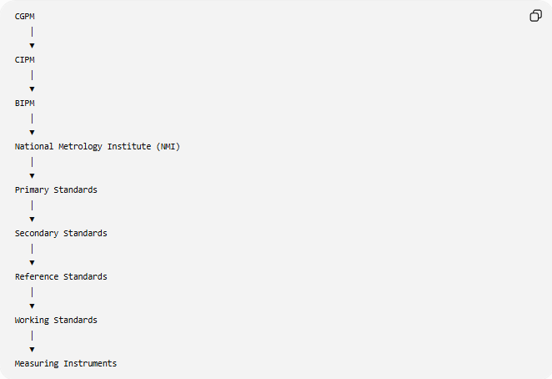
CGPM
│
▼
CIPM
│
▼
BIPM
│
▼
National Metrology Institute (NMI)
│
▼
Primary Standards
│
▼
Secondary Standards
│
▼
Reference Standards
│
▼
Working Standards
│
▼
Measuring Instruments

Functions of NMIs
# Source: AI Source: Provided by: [Data Path: Persons Table -> ID Column: 1, Name_En Column: Motasem Essam] -> From: [ChatGPT] on [7/17/2026]
National Metrology Institutes:
- Maintain primary standards.
- Disseminate measurement units.
- Calibrate national reference standards.
- Conduct scientific metrology research.
- Organize national measurement comparisons.
- Support laboratory accreditation.
- Develop measurement methods.
- Represent their countries in international metrology organizations.

Scientific Research
# Source: AI Source: Provided by: [Data Path: Persons Table -> ID Column: 1, Name_En Column: Motasem Essam] -> From: [ChatGPT] on [7/17/2026]
Many NMIs conduct research in areas such as:
- Quantum metrology.
- Time and frequency.
- Nanometrology.
- Electrical measurements.
- Optical measurements.
- Temperature measurement.
- Mass measurement.
- Dimensional metrology.
- Chemical metrology.

International Cooperation
# Source: AI Source: Provided by: [Data Path: Persons Table -> ID Column: 1, Name_En Column: Motasem Essam] -> From: [ChatGPT] on [7/17/2026]
NMIs cooperate through:
- The BIPM.
- The CIPM.
- International comparison programs.
- Regional metrology organizations.
- Mutual recognition arrangements.
This cooperation ensures that national measurements are internationally recognized.

International Comparisons
# Source: AI Source: Provided by: [Data Path: Persons Table -> ID Column: 1, Name_En Column: Motasem Essam] -> From: [ChatGPT] on [7/17/2026]
NMIs participate in international comparisons to:
- Verify national standards.
- Demonstrate measurement capability.
- Maintain international recognition.
- Improve measurement accuracy.
- Support calibration and measurement certificates.

Calibration Services
# Source: AI Source: Provided by: [Data Path: Persons Table -> ID Column: 1, Name_En Column: Motasem Essam] -> From: [ChatGPT] on [7/17/2026]
NMIs provide high-level calibration services for:
- Length standards.
- Mass standards.
- Temperature standards.
- Pressure standards.
- Electrical standards.
- Time and frequency standards.
- Chemical measurements.
- Optical measurements.
These calibrations establish the highest level of national traceability.

Examples of National Metrology Institutes
# Source: AI Source: Provided by: [Data Path: Persons Table -> ID Column: 1, Name_En Column: Motasem Essam] -> From: [ChatGPT] on [7/17/2026]
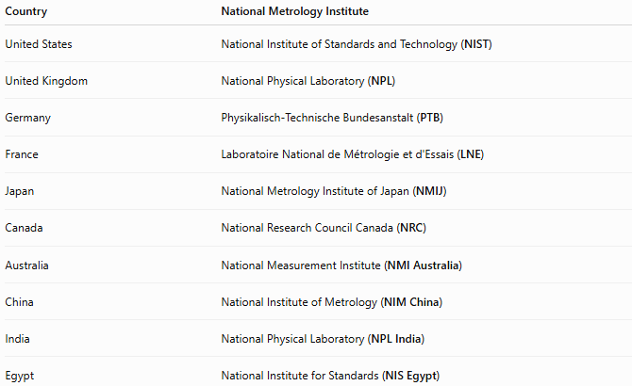
Country | National Metrology Institute
United States | National Institute of Standards and Technology (NIST)
United Kingdom | National Physical Laboratory (NPL)
Germany | Physikalisch-Technische Bundesanstalt (PTB)
France | Laboratoire National de Métrologie et d'Essais (LNE)
Japan | National Metrology Institute of Japan (NMIJ)
Canada | National Research Council Canada (NRC)
Australia | National Measurement Institute (NMI Australia)
China | National Institute of Metrology (NIM China)
India | National Physical Laboratory (NPL India)
Egypt | National Institute for Standards (NIS Egypt)

Measurement Traceability
# Source: AI Source: Provided by: [Data Path: Persons Table -> ID Column: 1, Name_En Column: Motasem Essam] -> From: [ChatGPT] on [7/17/2026]
NMIs provide national traceability.
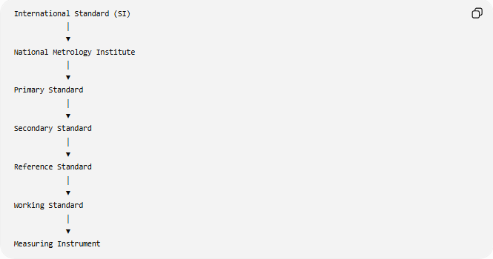
International Standard (SI)
│
▼
National Metrology Institute
│
▼
Primary Standard
│
▼
Secondary Standard
│
▼
Reference Standard
│
▼
Working Standard
│
▼
Measuring Instrument

Applications
# Source: AI Source: Provided by: [Data Path: Persons Table -> ID Column: 1, Name_En Column: Motasem Essam] -> From: [ChatGPT] on [7/17/2026]
NMIs support:
- Manufacturing.
- Engineering.
- Aerospace.
- Medicine.
- Telecommunications.
- Construction.
- Scientific research.
- Calibration laboratories.
- Environmental monitoring.
- International trade.

Everyday Importance
# Source: AI Source: Provided by: [Data Path: Persons Table -> ID Column: 1, Name_En Column: Motasem Essam] -> From: [ChatGPT] on [7/17/2026]
The work of NMIs helps ensure:
- Accurate grocery scales.
- Reliable fuel pumps.
- Correct electricity meters.
- Accurate medical devices.
- Precise GPS timing.
- Consistent product quality.
- Fair commercial transactions.

Advantages
# Source: AI Source: Provided by: [Data Path: Persons Table -> ID Column: 1, Name_En Column: Motasem Essam] -> From: [ChatGPT] on [7/17/2026]
National Metrology Institutes:
- Maintain national measurement accuracy.
- Provide SI traceability.
- Support scientific innovation.
- Improve industrial quality.
- Facilitate international trade.
- Strengthen national infrastructure.

Common Mistakes
# Source: AI Source: Provided by: [Data Path: Persons Table -> ID Column: 1, Name_En Column: Motasem Essam] -> From: [ChatGPT] on [7/17/2026]
- Confusing NMIs with ordinary calibration laboratories.
- Assuming every laboratory maintains primary standards.
- Confusing NMIs with the BIPM.
- Assuming NMIs create SI definitions (SI definitions are approved internationally through the CGPM and coordinated by the BIPM and CIPM).

Key Points
# Source: AI Source: Provided by: [Data Path: Persons Table -> ID Column: 1, Name_En Column: Motasem Essam] -> From: [ChatGPT] on [7/17/2026]
- NMIs are the official national organizations responsible for measurement standards.
- They maintain primary standards within their countries.
- They provide measurement traceability to the SI.
- They participate in international comparisons.
- They support science, engineering, manufacturing, healthcare, and trade.

National Metrology Institutes vs. BIPM
# Source: AI Source: Provided by: [Data Path: Persons Table -> ID Column: 1, Name_En Column: Motasem Essam] -> From: [ChatGPT] on [7/17/2026]
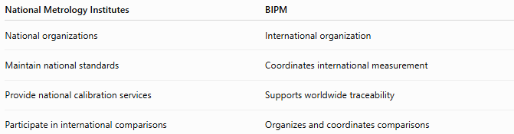
National Metrology Institutes | BIPM
National organizations | International organization
Maintain national standards | Coordinates international measurement
Provide national calibration services | Supports worldwide traceability
Participate in international comparisons | Organizes and coordinates comparisons

National Metrology Institutes vs. CIPM
# Source: AI Source: Provided by: [Data Path: Persons Table -> ID Column: 1, Name_En Column: Motasem Essam] -> From: [ChatGPT] on [7/17/2026]
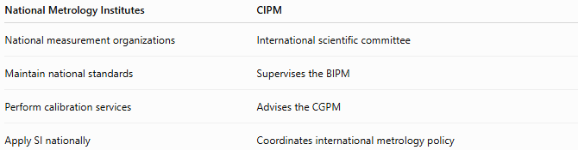
National Metrology Institutes | CIPM
National measurement organizations | International scientific committee
Maintain national standards | Supervises the BIPM
Perform calibration services | Advises the CGPM
Apply SI nationally | Coordinates international metrology policy

National Metrology Institutes vs. Calibration Laboratories
# Source: AI Source: Provided by: [Data Path: Persons Table -> ID Column: 1, Name_En Column: Motasem Essam] -> From: [ChatGPT] on [7/17/2026]
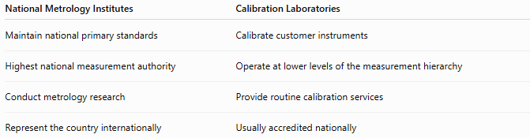
National Metrology Institutes | Calibration Laboratories
Maintain national primary standards | Calibrate customer instruments
Highest national measurement authority | Operate at lower levels of the measurement hierarchy
Conduct metrology research | Provide routine calibration services
Represent the country internationally | Usually accredited nationally

Conclusion
# Source: AI Source: Provided by: [Data Path: Persons Table -> ID Column: 1, Name_En Column: Motasem Essam] -> From: [ChatGPT] on [7/17/2026]
National Metrology Institutes (NMIs) are the official national authorities responsible for maintaining and disseminating measurement standards. They realize the International System of Units (SI) within their countries, maintain primary measurement standards, provide calibration and traceability services, conduct metrology research, and participate in international comparisons coordinated by the BIPM. Through their work, NMIs ensure that measurements made within a country are accurate, consistent, internationally recognized, and traceable, supporting science, industry, healthcare, engineering, and global trade.

